This VI is a simple tab control based web page designer.

It creates an html file according to user’s input.

And saves it into the folder which is named by the user

The folder is created in the same directory where our VI files are located.

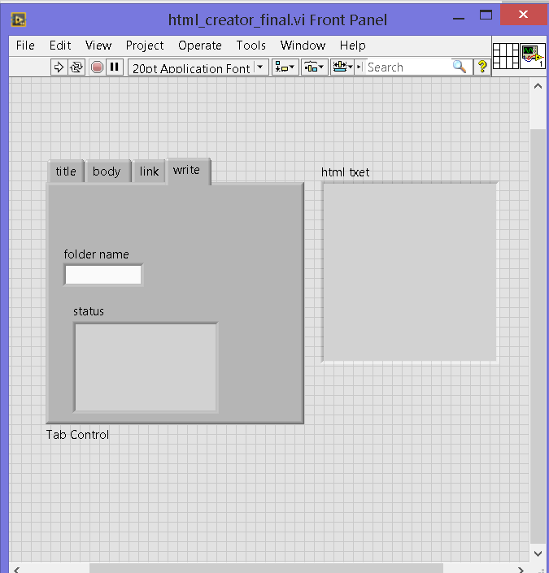

This is the control panel snip shoot before execution.

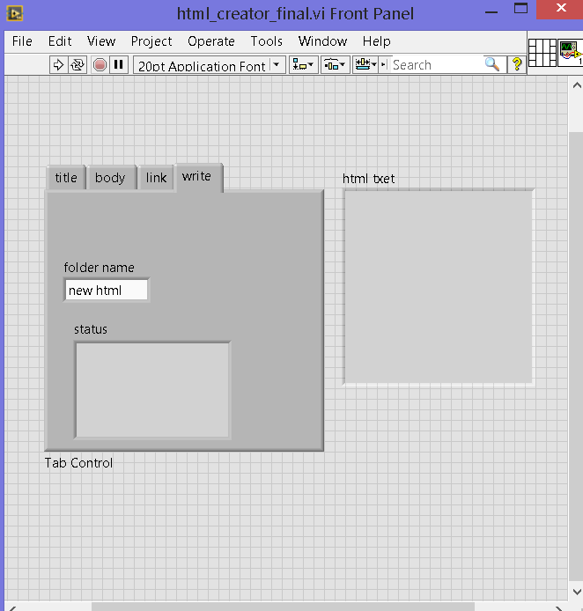

User specifies the folder name and runs it.

Then the title tab opens as below.

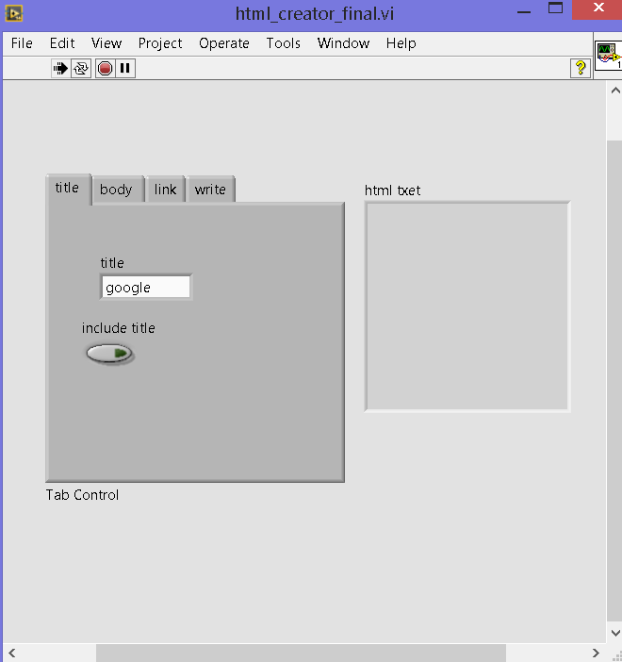

User types the name of webpage, and clicks include title.

Then the next tab opens.

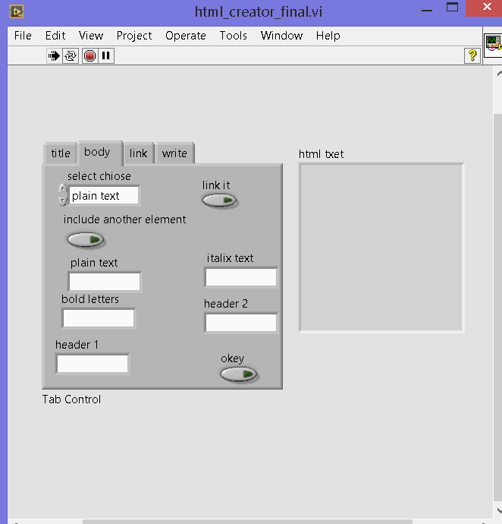

Here user gives the contents which are needed to be included in the body of html page.

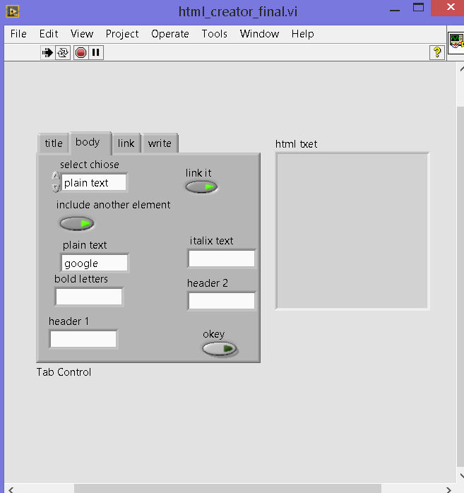

Here in this example I want to use the word google as a link to google.com.

So I turned on the “link it” control.

And I want to include another element so I turned on “include another element”.

Then I click “okey”

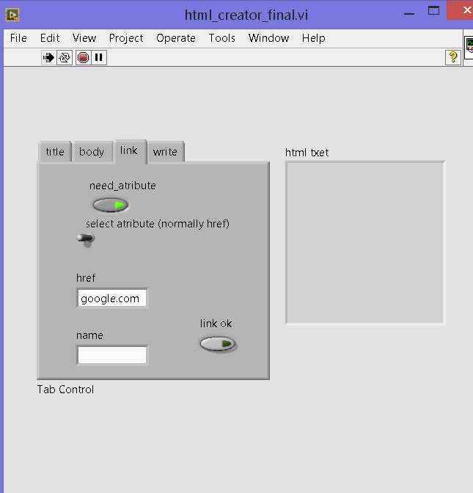

I want href attribute (normally href is the attribute which is used to include an external website)

So I did not altered the “select attribute switch”.

Then finally I click “link ok”

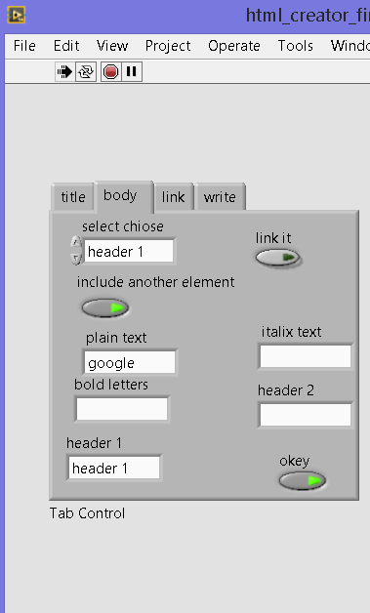

Then finally I given a header content as header 1

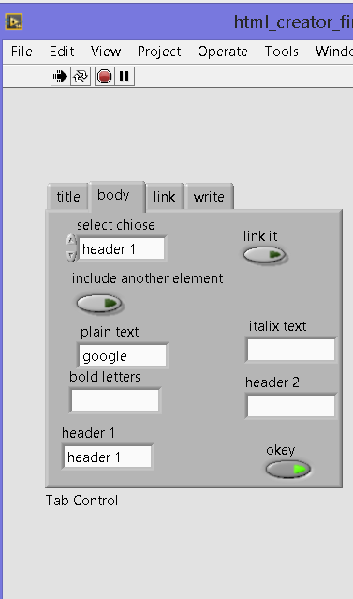

That’s all the content which I want to include in the web page.

So I turned off “include another content” and finally clicked “okey”.

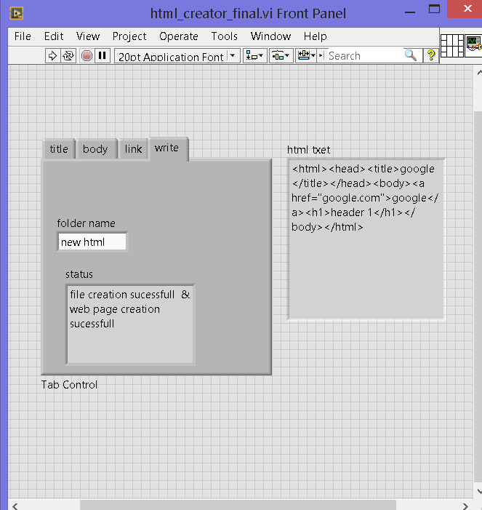

Finally VI ends up with file creation status.

(A new folder is created in the current VI’s path)

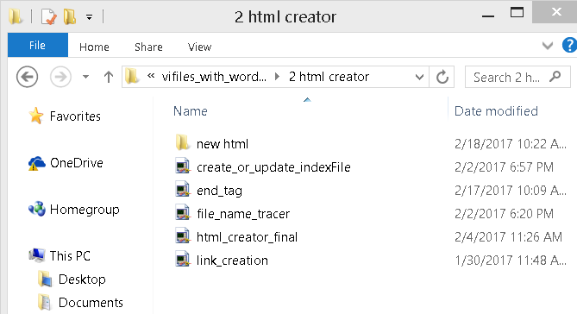

This folder contains an index file.

If we run it with internet explorer the below screen opens.

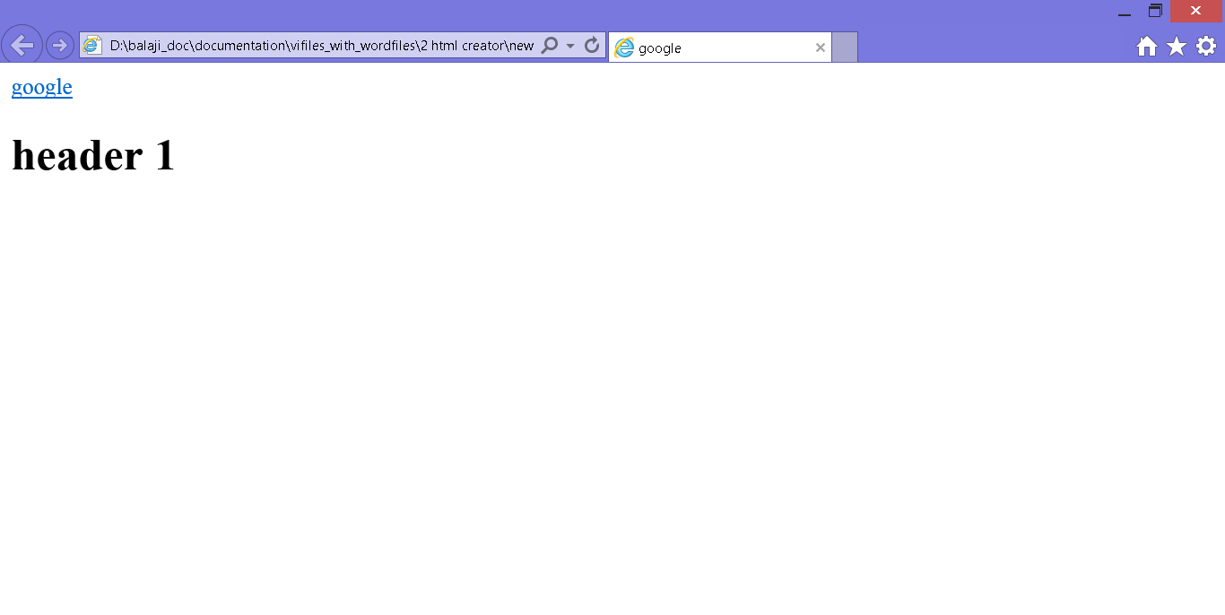

Title – Google

A link named Google links to google.com (if we click it, then it redirects us to google.com)

Header 1 is printed in large letters.